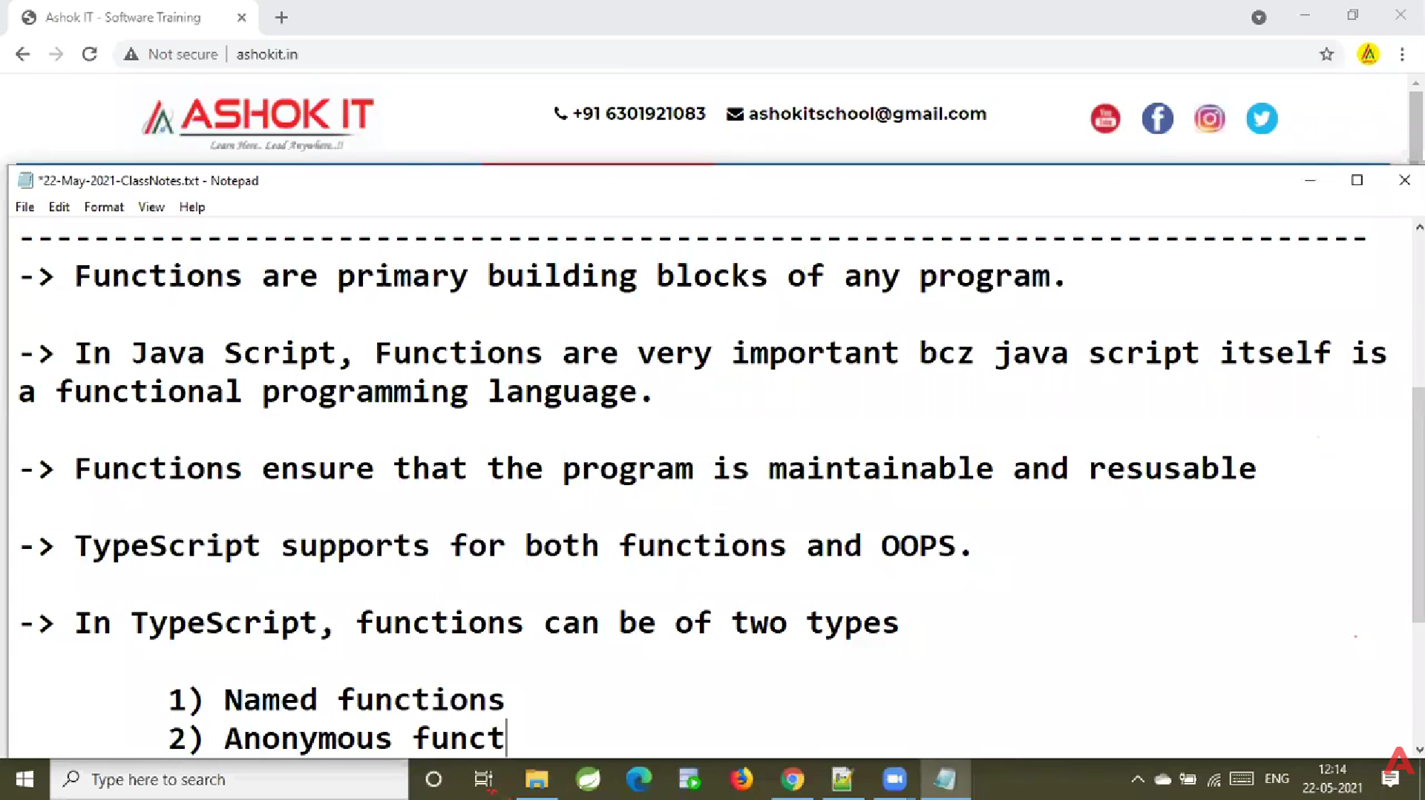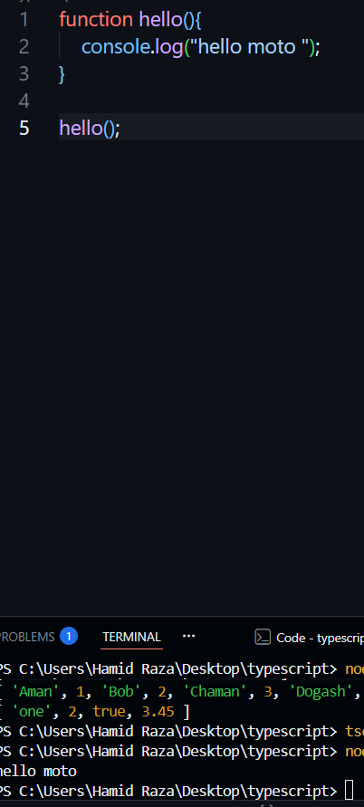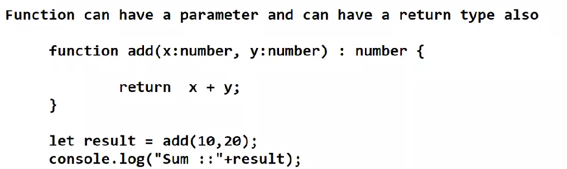
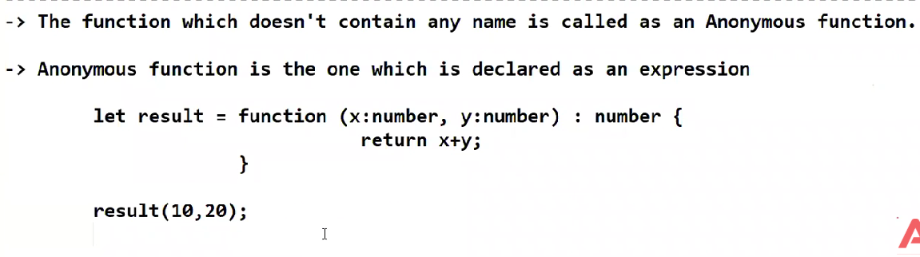
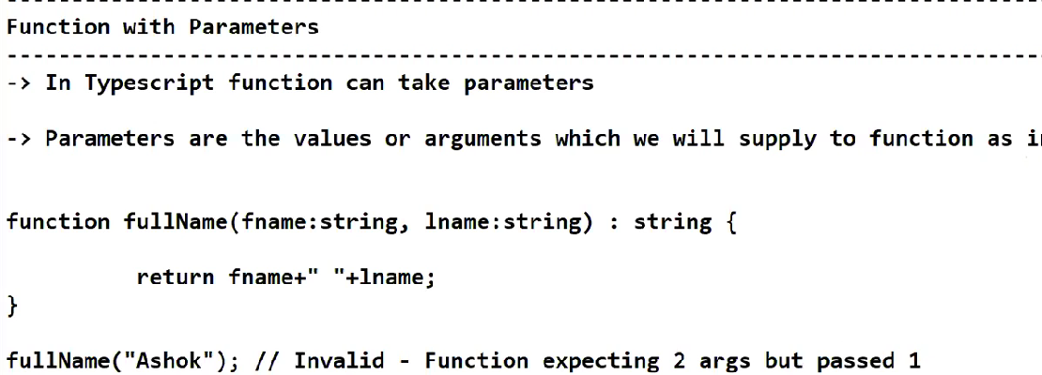
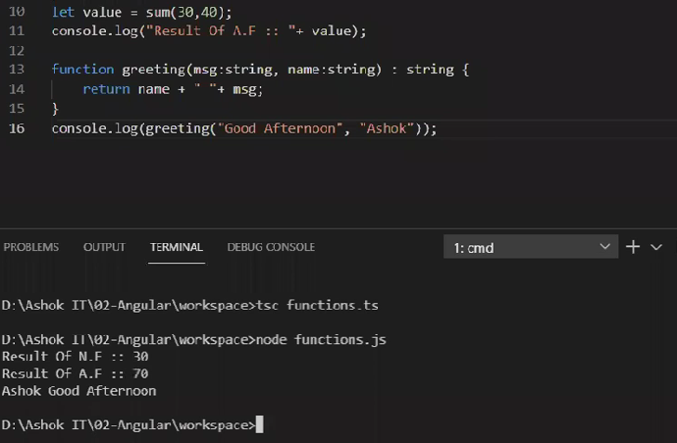
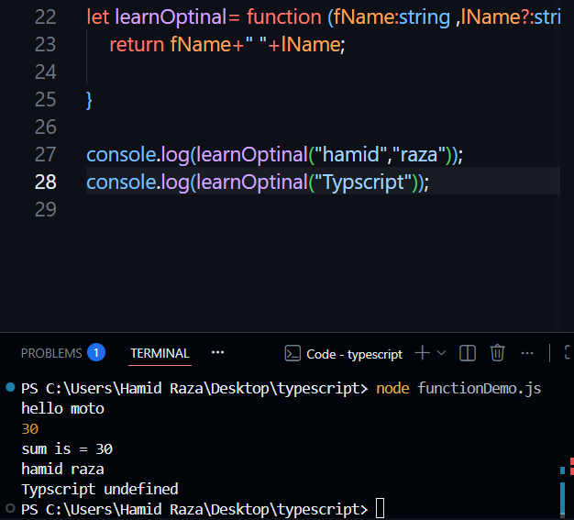
let wish= function (fName:string ,lName:string="hi"){
return fName+" "+lName;

}

console.log(wish("hamid","raza"));
console.log(wish("Typscript"));
output:-
hamid raza
Typscript hi
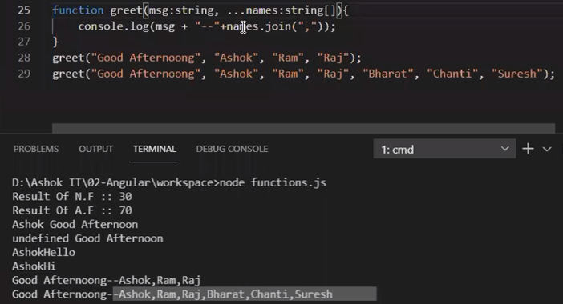
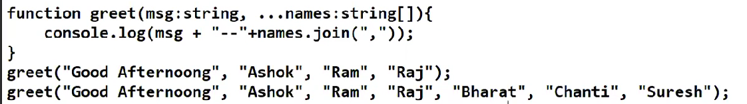
Here is the clearest, simplest, memory-friendly explanation of FUNCTIONS in TypeScript, with examples, diagrams, and tricks — so you will never forget.

⭐ What is a Function?
A function is a reusable block of code that performs a task.
In TypeScript, functions are typed, meaning:
✔ You must define parameter types
✔ You must define return type
✔ TypeScript checks everything for errors

------------------------------------------------------
🔥 1. BASIC FUNCTION (Simplest Example)
function greet(): void {
console.log("Hello TypeScript");
}
Breakdown:
- function → keyword
- greet → function name
- () → no parameters
- : void → return type (nothing returned)
- { } → function body

------------------------------------------------------
🔥 2. FUNCTION WITH PARAMETERS
function add(a: number, b: number): number {
return a + b;
}
Explanation:
- a: number → parameter 1
- b: number → parameter 2
- : number → function returns a number
✔ TypeScript will throw error if wrong type:
add(3, "hello"); // ❌ error

------------------------------------------------------
🔥 3. FUNCTION WITH OPTIONAL PARAMETERS (?)
function greetUser(name: string, msg?: string): string {
return `Hello ${name} ${msg ?? ""}`;
}

greetUser("Hamid");
greetUser("Hamid", "Good morning");
✔ msg? means parameter is optional
✔ If not provided, it becomes undefined

------------------------------------------------------
🔥 4. FUNCTION WITH DEFAULT VALUES
function multiply(a: number, b: number = 1): number {
return a * b;
}

multiply(5); // b=1 → returns 5
multiply(5, 2); // returns 10

------------------------------------------------------
🔥 5. VOID RETURN TYPE
Function returns nothing.
function logMessage(msg: string): void {
console.log(msg);
}
void = no return value.

------------------------------------------------------
🔥 6. NEVER RETURN TYPE
Used when function never reaches the end
(e.g., throws error or infinite loop)
function error(msg: string): never {
throw new Error(msg);
}

------------------------------------------------------
🔥 7. ARROW FUNCTIONS (Very Important)
Basic:
const add = (a: number, b: number): number => {
return a + b;
};
One-line arrow function:
const square = (n: number): number => n * n;
This is used a LOT in Angular & React.

------------------------------------------------------
🔥 8. FUNCTION TYPE (Assigning Types to Functions)
let calc: (x: number, y: number) => number;

calc = (x, y) => x + y;
✔ Makes code cleaner
✔ Allows only correct function signatures

------------------------------------------------------
🔥 9. REST PARAMETERS (...args)
Used to accept unlimited values.
function sum(...nums: number[]): number {
return nums.reduce((a, b) => a + b, 0);
}

sum(1, 2, 3, 4); // outputs 10
nums becomes an array of numbers.

------------------------------------------------------
🔥 10. OVERLOADING (Advanced but Easy)
Same function name, different parameter types.
function display(value: number): number;
function display(value: string): string;

function display(value: any): any {
return value;
}

display(10);
display("Hello");

------------------------------------------------------
🌟 EASIEST MEMORY TRICKS (NEVER FORGET)
1️⃣ Parameter comes inside ()
2️⃣ Return type comes after :
3️⃣ Arrow functions = shorter syntax
4️⃣ Optional parameter → ?
5️⃣ Default value → =
6️⃣ Rest parameter → ...

------------------------------------------------------
🌟 COMPARISON TABLE
Feature | Example | Meaning
Simple function | function a(){} | standard function
Parameter type | (a: number) | enforce type
Return type | : number | function returns number
Optional param | b?: string | may or may not pass
Default param | b = 5 | automatic value
Arrow function | ()=>{} | short syntax
Rest operator | (...a) | infinite arguments
void | : void | returns nothing
never | : never | never returns

------------------------------------------------------
🌟 MOST IMPORTANT EXAMPLE TO REMEMBER
function add(a: number, b: number = 0): number {
return a + b;
}

const multiply = (x: number, y: number): number => x * y;

function log(msg: string): void {
console.log(msg);
}
This covers:
✔ return type
✔ parameters
✔ default parameter
✔ arrow function
✔ void

------------------------------------------------------
🚀 Want NEXT?
I can teach:
🔹 Interfaces in TypeScript
🔹 OOP in TypeScript (Class, Constructor, Inheritance)
🔹 Type Aliases
🔹 Union & Intersection Types
🔹 How functions are used in Angular
Just say "Next topic".

